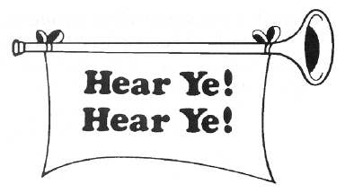

You Need To Be Applauded!
Your Name Needs To Be In Lights!
There Are Awards You Need To Win!

We Need To Know Who You Are!

WANTED

Clubs that have a positive membership gain. We need to know what you’re doing RIGHT!
We want to celebrate you.
We want to share your success.

PLEASE CONTACT YOUR MEMBERSHIP COMMITTEE IMMEDIATELY!

NGCMemberships@gmail.com
907-456-3066

