NGC Gardening School  Objectives  All gardeners can become accomplished horticulturists. To assist its members in achieving this goal, National Garden Clubs, Inc. created the Gardening Schools. A school is a series of four courses designed to:  - Stimulate interest in the growth of plant materials to their peak of perfection.  - Give the student an understanding of how and why a plant grows.  - Teach soil structure and methods for making the soil more productive.  - Provide an understanding of plants’ reactions to certain weather conditions and how to modify these conditions to encourage optimal growth.  - Provide an understanding of commercial and natural fungicides and pesticides, growth regulators, and other chemicals used in general horticultural procedures.  - Illustrate methods for rapid propagation.  - Offer plant identification instruction.  - Explore growing techniques for garden plants, vegetables, fruits, houseplants, trees, shrubs, and specialized styles of gardening.  - Develop a respect for and appreciation of plants and their roles in our lives and activities.  Gardening Schools provide current information to those interested in horticulture and related topics. The curriculum has been developed by National Garden Clubs, Inc. (NGC), and customized by the course instructors.  Classes are open to the public as well as garden club members. The program consists of a series of four two-day courses.  Garden club members who complete the series of four courses (with testing) are awarded the designation of Gardening Consultant. | NGC Gardening School  Directions to Light of Christ Lutheran Church  2400 SW 344th St.  Federal Way, WA 98023  From north of Federal Way:  - From I5, take exit 143 and merge onto  S. 320th St., heading west.  - Turn left onto 21st Ave SW  - Turn right onto SW 344th St.  From south of Federal Way:  - From I5, take exit 142B to merge onto WA18 West toward S. 348th St.  - Continue onto S. 348th St.  - Continue onto SW Campus Dr.  - Turn left onto 21st Ave SW  - Turn right onto SW 344th St.  Lodging  Here are a few hotels in Federal Way:  Clarion Hotel Seattle Federal Way  855-516-1090  Comfort Inn Federal Way  253-529-0101  Courtyard by Marriott Seattle Federal Way  253-529-0200  Hampton Inn & Suites Federal Way  253-946-7000  Quality Inn & Suites Federal way  253-835-4141 | National Garden Clubs, Inc.  Gardening School  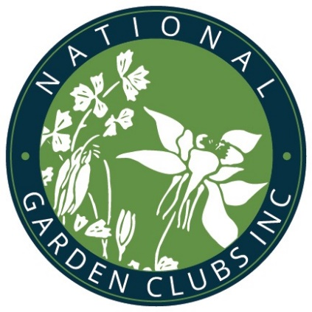  Series 12, Course 3  April 13-14, 2020  Light of Christ Lutheran Church  2400 SW 344th St.  Federal Way, WA 98023  Presented by Marine Hills Garden Club  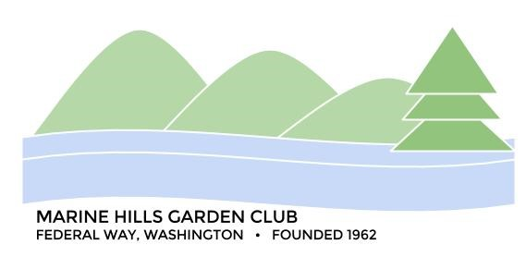  Affiliated with:  Chinook District of Garden Clubs  Washington State Federation of Garden Clubs  Pacific Region Garden Clubs  National Garden Clubs, Inc. (NGC)
NGC Gardening School  Course 3 Registration Form  April 13-14, 2020  Name: __________________________  Address: ________________________  City, State: _______________________  Zip+4: __________________________  Phone: _________________________  Email: __________________________  Garden Club: _____________________  District: ________________________  - Full-time, April 13 & 14 $85 ___  - Only Monday, April 13 $45 ___  - Only Tuesday, April 14 $45 ___  - Exam fee or Refresher fee $5 ___  - Late Fee (After April 1) $10 ___  - Cancellation Fee $10 ___  Total enclosed _________  No refunds for cancellations after April 6.  Registration includes complementary refreshments and lunches. We cannot accommodate special dietary requests.  Make check payable to:  Marine Hills Garden Club Gardening School  Mail to Registrar:  Dorothy Hitchcock  38126 30th Ct S  Auburn, WA 98001  dhitchcock72@gmail.com | NGC Gardening School  Course 3 Schedule  Monday, April 13  8:30 a.m. Registration (check-in)  8:45 a.m. Announcements,  Introductions  9:00 a.m. Houseplant Basics  10:30 a.m. Break  10:40 a.m. New Plant Development  and Evaluation  12:10 p.m. Lunch  1:00 p.m. Factors that Influence  Plant Growth  (Break about 2 p.m.)  3:15 p.m. Break  3:30 p.m. Exam  Tuesday, April 14  8:30 a.m. Registration &  Announcements  8:45 a.m. Container Gardening  (Break about 9:45)  11:00 a.m. Break  11:10 a.m. Supplemental topic  12:10 p.m. Lunch  12:50 p.m. Travel time to garden  1:10 p.m. Tour Rhododendron  Species Botanitcal Garden  3:10 p.m. Travel time  3:30 p.m. Exam  Note: Those refreshing or those not wishing to become NGC Gardening Consultants need not take the exams. | NGC Gardening School  Course 3 Recommended Reading  The New Western Garden Book: The Ultimate Gardening Guide (Sunset Western Garden Book, 9th Edition, Editors of Sunset  Botany for Gardeners, Brian Capon  Secrets to Great Soil (Storey’s Gardening Skills Illustrated), Elizabeth Stell  Required Reading  (for Garden Consultant status)  The National Gardener magazine,  subscribe (free online) at www.gardenclub.org  Committee  National Garden Clubs, Inc. Gardening School Chair: Barbara Hadsell  Washington State Federation of Garden Clubs Gardening School Chair Brynn Tavasci  Gardening School Registrar: Dorothy Hitchcock  dhitchcock72@gmail.com  Marine Hills Garden Club President and  Local Gardening School Chair:  Debbie Angel 253-486-2326  debbielangel@gmail.com

